Chapter test—Chapter 1 Objects in motion
This test is a mixture of multiple choice questions and short answer questions. For the multiple choice questions, please circle the correct answer. For the short answer questions, please write on the lines provided. Each of the multiple choice questions is worth one mark. The short answer questions have their marks allocated next to the question.

1 The change in position of an object and its direction is known as:
A displacement
B distance
C average speed
D average velocity

2 How long would a car travelling at a speed of 60 km/h take to cover a distance of 90 km?
A 1½ hours
B 2 ½ hours
C 3 ½ hours
D 4 ½ hours

3 Which line on the following graph represents a deceleration?

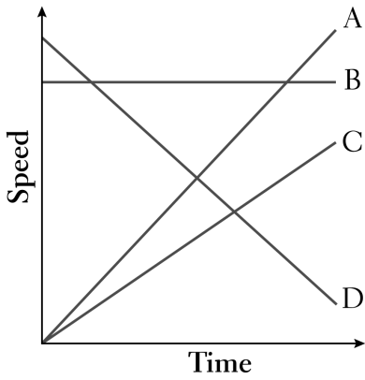
A A
B B
C C
D D

4 Which line on the following graph represents a constant speed?
A A
B B
C C
D D

5 The rate of change of speed is known as:
A average speed
B average velocity
C change in velocity
D acceleration

6 An object starts from rest and accelerates at 5 m/s/s. After 4 seconds, its speed will be:
A 0
B 10 m/s
C 20 m/s
D 30 m/s

7 The tendency of an object to resist changes in its motion is called:
A inertia
B weight
C friction
D work

8 Newton’s law, known as the law of inertia, is:
A his first law
B his second law
C his third law
D none of the above

9 ‘If an object has zero acceleration, the object must be at rest.’ This statement is:
A always correct
B sometimes correct
C never correct

10 An object is acted upon by a thrust force of 50 N and a total frictional force of 40 N. The net force will be:
A 10 N backwards
B 10 N forwards
C 90 N backwards
D 90 N forwards

11 The size of the acceleration acting on an object of mass 10 kg that has a net force of 3 N acting on it will be:
A 13 m/s²
B 3.33 m/s²
C 0.3 m/s²
D 30 m/s²

12 A cyclist has a weight of 500 N, the road pushes up with 500 N, the thrust force is 30 N and the drag is 32 N. The cyclist will be:
A stationary
B accelerating
C decelerating
D travelling at constant velocity

13 When you hit a tennis ball with a tennis racquet, the action force is the force of the racquet hitting the ball and the reaction force is:
A the ball hitting the racquet
B the jarring force you feel through your hand
C the weight force on the ball
D the weight force on you

14 Complete this statement: ‘When objects collide, the law of conservation of _______________ applies.’
A mass
B acceleration
C momentum
D force

15 Momentum is measured in units of:
A newtons
B kg
C kg m·s
D m/s

16 Energy is:
A a vector quantity
B a scalar quantity
C a force
D none of the above

17 In a perfect collision between two objects, one object loses 65 kg m·s of momentum and the other object would:
A also lose 65 kg m·s of momentum
B gain nothing
C gain 130 kg m·s of momentum
D gain 65 kg m·s of momentum

18 The type of energy that involves mass, gravity and height is:
A kinetic
B gravitational potential
C work
D elastic potential

19 Complete this statement: ‘When a force acts through a distance, _______________ is done.’
A kinetic energy
B gravitational potential
C work
D elastic potential

20 The elastic potential energy of a spring compressed by a distance of x = 0.1 m and with a spring constant k of 40 N/m would be:
A 4 J
B 2 J
C 0.4 J
D 0.2 J

21 Group the following quantities as either scalar or vector:
displacement, speed, velocity, force, distance, momentum
a Scalar quantities: (2 marks)

b Vector quantities: (4 marks)

22 In the following position–time graph:
a describe the motion of the object at time t = 3 seconds. (1 mark)

b calculate the average speed of the object for the first 2 seconds. (2 marks)

c calculate the average speed of the object for the whole 5 seconds. (2 marks)

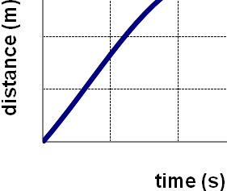

23 The speed limit on some Australian highways is 110 km/h. What is this speed in units of metres per second (m/s)? (2 marks)

24 Draw dots on the section of ticker tape below to indicate deceleration. (2 marks)

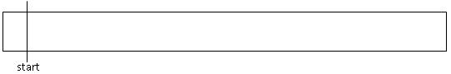

25 Calculate the average speed of a runner who runs 500 m in 80 seconds. (2 marks)

26 Calculate the distance covered by a car travelling at 25 m/s for 3 minutes. (3 marks)

27 A small stone is dropped from the top of a tall building. It takes 3 seconds to reach the ground. The acceleration of the stone on the way down is 10 m/s². Calculate the speed of the stone as it hits the ground. (3 marks)

28 Does a speedometer in a car measure average or instantaneous speed? Explain your answer. (2 marks)

29 Which way do passengers standing in a train move when the train comes to a sudden stop? Explain your answer. (3 marks)

30 As you are completing this test, the force of gravity is acting on you. Why then don’t you move? (2 marks)

31 Calculate the net force acting on a 30 kg mass accelerating at 0.4 m/s². (2 marks)

32 A rock of mass 2 kg is falling through the air. A force of 5 N air resistance acts on the rock.
a What is the weight force of the rock? (1 mark)

b What is the size of the net force acting on the rock? (1 mark)

c What will be the size of the acceleration of the rock? (1 mark)

d Why is your answer to part c not 10 m/s²? (1 mark)

33 Draw a diagram showing an apple hanging from a branch. Carefully draw two forces that act on the apple. Label each force. (4 marks)

34 What is the reaction force to your own weight force? (2 marks)

35 Calculate the momentum of a 0.5 kg ball travelling at 4 m/s. (2 marks)

36 Which is better from a safety point of view: coming to a sudden stop or coming to a gradual stop? Explain your answer. (3 marks)

37 A collision involves a change in momentum of 40 kg m·s a period of 0.2 seconds. Calculate the size of the average force involved. (2 marks)

38 Use lines to match up the term with their definitions. (4 marks)

gravitational potential energy | energy stored when compressed or stretched
kinetic energy | force acting through a distance
work | energy stored when raised to a height
elastic potential energy | energy of movement

39 Which has more kinetic energy: a truck of mass 3000 kg travelling at 10 m/s or a car of mass 1000 kg travelling at 20 m/s? (5 marks)

40 Which has more gravitational potential energy: a book of mass 0.6 kg raised to a height of 2 m or a chair of mass 1 kg raised to a height of 1 m? (5 marks)

